KEPPEL SANDS STATE SCHOOL
2024 Term 1 Week 1 Phone: 07 4934 4760 Email: prinicpal@keppelsandsss.eq.edu.au

KEPPEL KINDNESS
A Newsletter for the Keppel Sands State School Community
A friendly school where every child succeeds.

F
ROM THE PRINCIPAL’S DESK
Good afternoon, parents, students and community members, I would like to take this opportunity for formally introduce myself to those who may not already know me in our community. My name is Mrs Morris and the long-standing students and staff at the school know me as Miss Sam. I have lived in Keppel Sands for over 20 years. I have taught and watched many of our local children grow up and become young adults. At the school I have held many roles, in the early days I was a contract and supply teacher before taking up acting principal roles for past principals, then taking up a permanent fraction position at the school. Keppel Sands is my home, my hope is the transition for staff, students and families will be positive and effortless. I look forward to meeting both our new and long-standing families throughout this term.
Sneak Peek into the classroom learning this term.
Students have hit the ground running as they come up to completing their first assessment task for Maths where they have been learning about Symmetry, Location and Transformation and language associated with this area of mathematics. The next area will be Number and Algebra.
In English students are exploring Imaginative texts this unit consists of two assessment tasks being completed one a character analysis with the follow up of a narrative.
Science, students are learning about chemical science and investigating how materials and their properties change when heat or cold is combined along with irreversible and reversible change.
Stay tuned for more updates into our learning this term.

Staff update:
Mr B has decided not to return this term which means we will have invited Ms McColl to join us on class every Wednesday to ensure consistency with staff throughout our week and have less disruption to students having to have another change in their term.
Additional School Leader for 2024
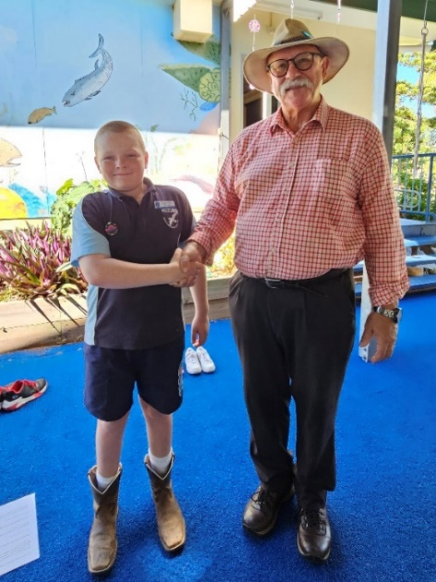
At parade on Friday afternoon Luke was presented with his School Leadership badge. Luke has recently returned to Keppel Sands State School and has shown great maturity and role-modelling for our younger students in his behaviour and effort at school, as well as exemplifying the Keppel Kindness attributes.
This leadership role will see Luke join our two other Year 6 Leaders in taking on increasing levels of responsibility within the School community.
Welcome back to the Keppel Sands community, Luke!

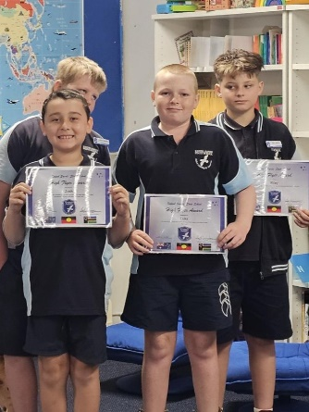
Student of the Week Awards
WEEK 1 saw Josh, Riley and Luke receive Student of the Week awards, presented at our Welcome Parade.

Josh: You have made a fantastic start to 2024. You have been super helpful all this week and followed all school rules perfectly. Super work!
Riley: You have made an amazing start to 2024. You have shown great leadership skills this week. Well Done!
Luke: You have made a flying start to 2024. You have been helpful and polite all week. Great Work!

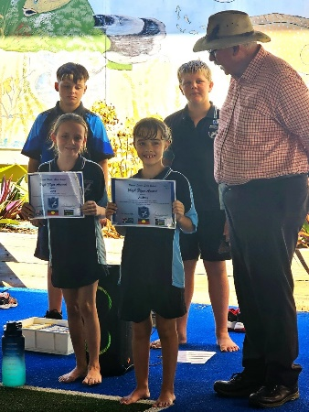
WEEK 2 Student of the Week awards were presented to Luna and Audrey.
Audrey: You have been amazing during Term 1, Week 2. You always work well in class and have been willing to show teachers your remarkable knowledge. Well done!

Luna: You have been a star during Term 1, Week 2. You have worked well in class and remembered to “Stay in your own lane.” Fantastic!

Week 3 News with Mrs McColl

It has been great to settle back into the year with the Keppel Sands students. Students have been split into the senior and junior year levels for both Mathematics and English Unit lessons so far this term.

In Mathematics we have started the year learning about concepts such as symmetry and transformations (flips, slides & turns). This week we are moving onto learning about mapping skills (including compass directions, grid references and directional language), with the Year 6s also learning about ordered pairs in relation to Cartesian planes and describing transformations.
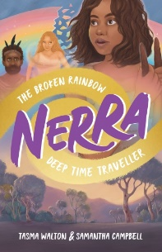
In English, in Years 4 to kjenk906, we are reading the novel, Nerra, which was only published in October 2023. The students have been revising language features and thinking about why an author chooses particular types of language when writing a book. Students are especially focussing on characterisation, how and why an author describes the characters looks, actions, thoughts, and feelings during the novel.

Prep to Year 3 students are also looking at how characters are portrayed in picture books, using both language and illustrations. So far, we have enjoyed looking at Little Kiwi and Fidgety Fish.

Consent Forms to be Returned

We haven't received consent forms from some parents for the following-
- RI (Religion)
- Hearing Program
- Student Wellbeing Program
- New consent for Prodigy.com & Epic

If you would like your child/ren to participate, please return asap. Students without consent cannot participate. You can stop consent at any time by writing a note to the school.

