KEPPEL SANDS STATE SCHOOL
2024 Term 1 Week 7 Phone: 07 4934 4760 Email: prinicpal@keppelsandsss.eq.edu.au

KEPPEL KINDNESS
A Newsletter for the Keppel Sands State School Community
A friendly school where every child succeeds.

F
ROM THE PRINCIPAL’S DESK
Week 7 already where does the time go. There is a lot on information in this newsletter so I will keep my part brief. I would like to thank our parents for their patients and support as we worked through the past weeks implementing some minor tweaks to enhance our track for success providing Equity and Excellence in the way we interact and maximise learning days for your children. I can announce I will be continuing on in this space for term 2. Have a great week ahead.
Miss Sam
Student of the Week Awards
Congratulations Adam for demonstrating respect and kindness to peers and staff, Alex for sharing his scientific knowledge. Micha achieved his Golden Words. Week 6 Congratulations to Philip for his magnificent math brain and for Sophia for showing initiative at lunch time packing away activities Well done!
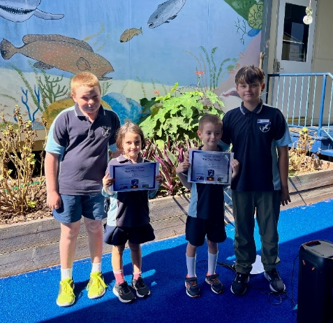
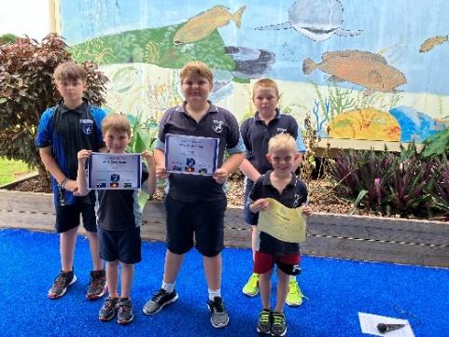

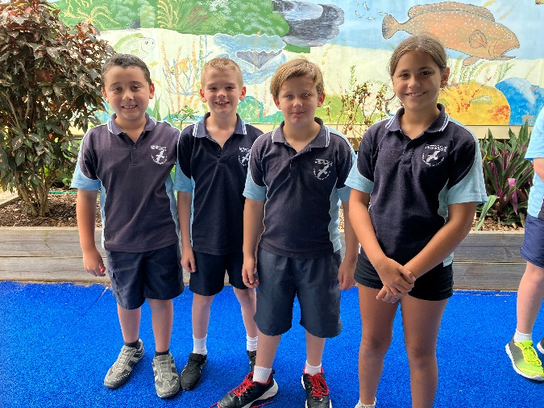
Congratulations to our Student Council
Welcome our 2024 student council members Noah, Josh, Travis and Immogen. Students in years 4-6 were given the opportunity to nominate themselves or have other students nominate them for student council. Students participated in a secret ballot so student’s had the opportunity to vote without peer pressue. Students were asked to provide a reason for their vote to ensure we are voting for the right people not just friendship groups. Though we know we had a couple of disappointed students, our elected council will do a wonderful job listening to ideas put forward from our school community.

Week 7 News with Mrs McColl
The term is scooting by, as we are well into Week 7.

This week, in Mathematics, the Year 4 students are finishing their unit on number and fractions. Next week they will begin a unit on Data. Year 5 and 6 students are learning about how decimals are related to fractions, being able to place these on number lines, and being able to sequence them. Year 6 students are also consolidating their knowledge of percentages and negative numbers. They will also begin a Data unit for the last few weeks of Term 1.

In English, in Years 4 to 6, we have read a short story called “Dear Oma.” This story was set around Federation time, 1900-1901, which is a topic we are also learning about in HASS. This story is to be inspiration for a narrative/story set in the past, that the students are currently planning for.

Prep to Year 3 students are also busy planning characters and settings for their narratives which they will begin writing soon. One of their characters will be one form a book we have read in class, which they will incorporate into their own story. I look forward to reading the creative responses these students have, when they begin writing their stories.

JANE MCCOLL | CLASSROOM TEACHER

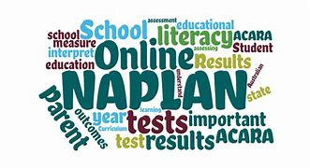
NAPLAN Update
Over the next couple of weeks, we will start our NAPLAN practice tests with students in years 3 and 5. Our timetable for testing will start on Wednesday in week 8 with our last session being on the Friday. Attendance is important throughout this time. Should you have any questions please do not hesitate to phone and make a time to have a chat regarding your child.

Sharing Food at lunchtime
Over the past couple of weeks staff on eating duty have witnessed some students trading/sharing food with other students, not necessarily related. Whilst we appreciate siblings may not always eat or like what’s in their lunch box, we discourage students from sharing/trading foods for many reasons such as alergies, food specific diets and parent feedback. If you can remind your child/children not to share with other students at school and to take home unwanted/uneaten food that would be wonderful.

Headlice Infestation
Letters have been sent home recently regarding headlice at school. We recommend regular checking of your child’s hair and if any headlice are found to notify the school immediately and seek treatment to avoid further investations occuring in the school. If your child has long hair we strongly recommend their hair is tied up in hope of reducing the spread.

How we use EPIC and Proidgy Programs at School
It has been great to see students engaged with two new learning programs we have introduced this term.
Epic is a leading digitial reading platform built on a collection of 40,000+ popular, high-quality books from 250+ of the world’s best publishers. It is designed for students 12 and under. Teachers can assign books to students based on interests and reading levels across whole school. Epic provides a comprehension survey at the end of a book which checks for understanding of the text building on skills and knowledge within a text.
Prodigy is a digital platform covering Math and English content inline with the Australian Curriculum. Whilst it presents as an online game staff create assessments/ campaigns for students based on current learning in the classroom or areas where students require more support. This program allows teachers to monitor progress, check for understanding of concepts being assigned and builds on students knowledge skills. We have specifically instructed students this is a school based program and to be used at school.

Q-Parents starting term 2 – All aboard!
Why Q-Parents? QParents is a secure, online portal that has been created by the Department of Education to provide parents of Queensland state school students with 24-hour access to their child's information.
The portal allows you to securely access information about your child and communicate directly with your child's school from any location.
Features and benefits of QParents :
- Access attendance details
- Monitor behaviour reports/ plans
- Access report cards and assessment dates
- Be up to date with upcoming events
- Check in our the schools term timetable.
- Receive and pay invoices without having to come into the school
- View your payment history
It’s a simple sign up process that we would be happy to assist with at school at the start of term 2. If you would like us to hold an information session please send your expression of interest to admin@keppelsandsss.eq.edu.au

Three way Parent / Student conferencing Week 9
This term we would like to offer parents and their child the opportunity to check in on their progress as we near the end of our assessments. This is a great chance to share any concerns or feedback relating to your childs educational needs and Well-being. Times and dates will be sent home this week.

Cross Country date change
In previous years the cross country has been organised by Keppel Sands State School and completed here. A decision was made to provide our students with the opportunity to participate in a different location in cooler weather next term with Cawarell State School hosting this event. We will provide further information next term once dates have been finalised.

Braveheart’s visit
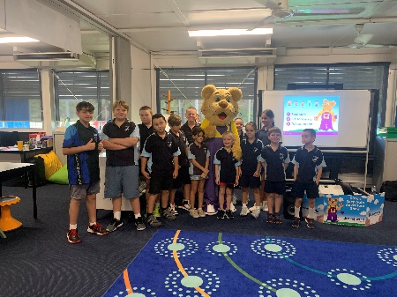
On Tuesday our students had the pleasure of seeing the Braveheart’s show live for the last time before they transition over to a digital platform. Students listened to important messages about personal safety through stories, song and dance. The key message was ensuring our students know 5 adults they have on their safety team that they can go to at any time with a problem good or bad. It was great to see all students engaged and participating. They enjoyed giving Ditto a big hug at the end of the show.

Student Council’s 1st event Easter Raffle
The student council will be selling tickets at school from Monday week 8 at $1 a ticket and will be drawn 28th March. Winners will be announced or sent a message to collect.

Student Council free dress day
Held on the 28th March a gold coin donation. Sun safety clothing must be worn along with our normal school shoes.

Upcoming fire and lockdown drills
Each term schools are required to perform practice drills to ensure in the event of an emergency staff and students will calmly know what is expected of them should a fire or lockdown occur in our school. In Week 7 this term we will hold a fire and lockdown drill.

Date Claimers

Library day every Friday
16th March - Council Elections
26th March - Hearing screening
28th March- Easter raffle draw and Free Dress Day
29th March - Easter

